Dave Marks, PE, O’Neal, Inc.
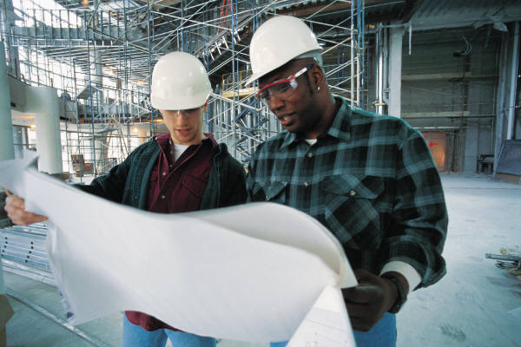

Renovating facilities of any kind is tricky business. There are the unknowns for one thing: the patchy documentation; the gotchas behind the walls or under the slab; the awkward fit of repurposed space within existing structures. Then, you have to determine what’s salvageable and how to integrate new construction within the legacy building. Repurposing old facility space can be far more challenging than designing greenfield facilities with the luxury of starting with a clean sheet.

How cGMP + Legacy Facilities is a Game-Changer
Renovating for GMP space is an entirely different ball game. Manufacturing facilities typically have to minimize downtime, requiring a realistic strategy for segregating construction activities in adjacent space and preparing existing utility systems for expanded utilization. The original facility adjacencies will be disrupted, requiring thinking through the impact on supporting operations – warehousing, weigh/dispense, QA labs, solution preparation, equipment cleaning/sterilization, gowning and locker rooms. Consider how the throughput from new or expanded operations will affect these support spaces. The flow of people, materials, equipment, product and waste through the facility will likely be disrupted as well. A well-planned facility expansion or renovation will guard the integrity of GMP traffic and cleanroom transitions for both new and remaining operations. Bottom line, the space program is not limited to the user requirements for the new space; the impact on existing operations must be understood.

Process Operations: Are You Asking the Right Questions?
There are abundant issues associated with legacy process systems as well. Will new equipment be required, or can existing systems be adapted to new process requirements? How will new process systems tie into existing clean utilities and CIP infrastructure? How about tie-ins to existing data historians, SCADA, MES and BAS systems? Are process operations open, closed, or a mix? What is the impact on the degree of facility segregation that required to protect product quality? What are the utility requirements for the new space? How will its load diversity affect other manufacturing operations within the facility? What approach will the renovated facility take to cleaning and bioburden control? These are just some of the many process-related questions that need to be answered as part of scope definition for the project. This underscores the importance of understanding new and existing process operations before committing to a project scope, budget and schedule.

The objectives of the project often necessitate a process-oriented approach to cGMP renovations and expansions. If process remediation is one of the objectives of the project, one needs to take a deep dive into the manufacturing complexities to understand the root cause of issues. If the objective is to expand throughput, then the material balance and timing of operations must be well understood for each product before modeling the process and identify bottlenecks for each scenario. And of course, anytime any disruption to an existing GMP manufacturing operation requires an understanding of the impact on process validation as part of decision-making. Is this a new manufacturing process? How then will the team address interaction and degree of separation required to prevent cross contamination with other products. These are just a few examples of how projects in legacy pharmaceutical facilities are unique.

The Necessity of a Different Mindset
It’s clear that GMP renovations require a different mindset for everyone on the project team – the owner, architect, engineer, construction manager, C&Q team – to ensure a successful outcome. This is where working with an experienced team with the right skillset really pays off. There’s no substitute for a project team that is properly equipped to anticipate the challenges ahead and address them in the project execution plan.

