John Baker, Director of Marketing, O’Neal, Inc.

For any significant capital investment project, whether it be increasing existing capacity, establishing a new facility, etc., there are several actions performed over the course of the project that determine the project’s level of success. Those actions can be part of a carefully planned front-end process called pre-project planning (sometimes known as feasibility analysis or conceptual planning) or can occur reactively as problems or questions transpire.

Pre-Project Planning

The Construction Industry Institute (CII), a research-focused collaboration that brings industrial owners and design and construction companies together in a shared desire to improve industry practices, defines pre-project planning as “the process of developing sufficient strategic information with which owners can address risk and decide to commit resources to maximize the chance for a successful project.” Common steps in pre-project planning include project organization, selecting project alternatives, defining the project, and determining paths forward. While these actions do not guarantee project success nor are they comprehensive, they do encompass critical components of planning for and executing a successful project.

Construction Industry Institute Study

CII conducted a study, Pre-Project Planning: Beginning a Project the Right Way¹, on the impact the pre-project planning process can have on capital facility expenditures. Study results showed clear differences in outcomes across project performance criteria, and benefits of pre-project planning are listed below.

Benefits of Pre-Project Planning
- Improved cost predictability
- Improved schedule predictability
- Better attainment of operational and production goals in the first six months of operation
- Better achievement of business goals
- Better definition of risks
- Fewer scope changes
- Greatly reduced probability of project failures

The study contrasted three levels of project planning (High, Medium, Low) that were based on a set of commonly accepted project development activities. Projects in the study were assigned a project planning level relative to those criteria. The research team then measured 54 projects to determine performance in five categories: cost, schedule, percent attainment (operating capacity), percent utilization (operating uptime), and financial (business case criteria).

Analysis showed superior performance in each of the five categories for projects with “high” levels of planning. These variances held up in operating and business case categories as well. Average asset utilization for highly planned projects was 103%. Projects with low levels of planning averaged 85% utilization. 81% of highly planned projects met financial goals compared to 65% of projects with low levels of pre-planning. Stated another way, just over one-third of projects with low planning levels did not meet financial (business case) expectations once those projects were put into operation. From another perspective, projects with the lowest levels of pre-project planning have the greatest risk of failure from an operating and financial performance standpoint. The table below illustrates the performance by pre-planning groups.
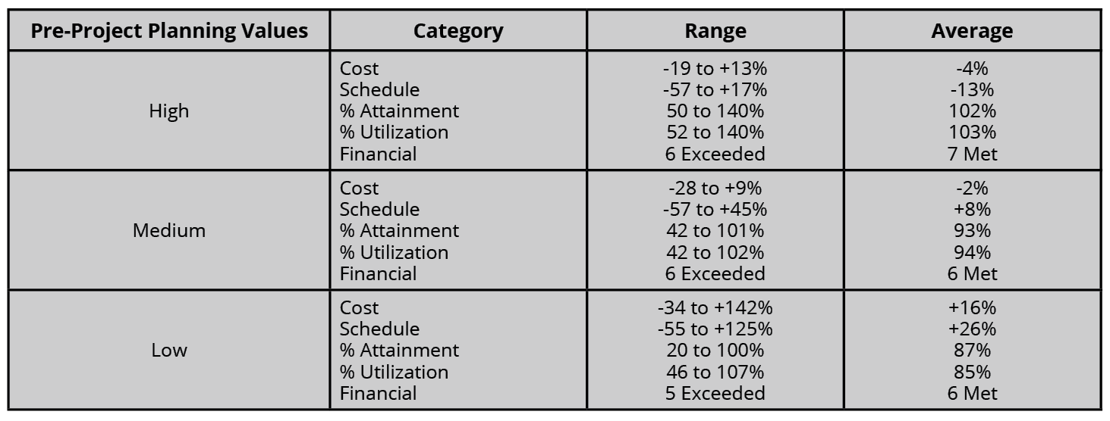

O’Neal’s Project Development and Delivery

O’Neal created and utilizes a process, Project Development and Delivery, that is based on client best practices and CII’s work. The approach begins with a project problem statement that outlines the situation to be addressed and how addressing that situation creates an opportunity for growth, cost savings, higher efficiency, safety, or increased product quality. The problem statement becomes the basis for building a team, writing objectives, developing a business justification, developing scope and boundaries, establishing project success criteria, and ultimately evaluating project options. This work occurs without an initial need for design and then progresses to developing a design basis and conducting options analysis that are carried forward into a conceptual package. Ultimately, the goal is to select an option to carry forward that accurately responds to the project problem, has a solid scope of work with boundaries, and operates within a framework of a clearly defined business justification.

O’Neal’s use of Project Development and Delivery for almost 20 years has shown results consistent with the CII findings. Whether O’Neal uses this internal process or uses a similar client process, cost and schedule predictability are high. In fact, O’Neal is able to guarantee cost and schedule on projects that have gone through a thorough pre-project planning effort by the end of appropriation approval, typically with 35-45% design completion.

Plan Now to Save Later

While front-end planning, or pre-project planning, efforts are sometimes sacrificed in the name of speed or cost, research shows that the cost of project planning provides substantial savings in every aspect of project performance.

Since 1975, O’Neal has been successfully delivering capital projects in the process chemical, food and beverage, automotive, biopharm, manufacturing, and pulp and paper markets worldwide. O’Neal is an integrated engineering and construction firm that combines overall project planning, design, procurement, and construction to create cost-effective capital solutions. With all design and construction professionals in-house, O’Neal’s clients benefit from a true collaboration of disciplines. For more information, visit O’Neal at www.onealinc.com.

¹ Construction Industry Institute. (1994, December). Pre-Project Planning: Beginning a Project the Right Way (No. 39–1). Bureau of Engineering Research | The University of Texas at Austin. https://www.constructioninstitute.org/resources/knowledgebase/project-phases/concept/topics/rt-039

