Chris Connelly and Matt Doak, O’Neal, Inc.

In a world of ever-changing technology for process improvements, it is easy to be overwhelmed with the vast number of products, technologies, and possible applications. The following information will help you better understand Vertical Lift Modules (VLM) and if they may be the right solution for you.

VLM are a type of goods-to-person automation system that utilizes the clear height in a building to reduce operator fatigue, while increasing both picking accuracy and throughput. It accomplishes these benefits by vertically storing SKUs/products onto large trays that can be subdivided into compartments. This configuration condenses the storage footprint and optimizes the cube. A VLM has multiple trays-per-machine stacked vertically which are delivered automatically to an operator based on either customer order information or manual request. The order information is sent to the machines by a user’s warehouse management system (WMS) or Enterprise Resource Planning (ERP) system. The VLM’s warehouse control system (WCS) determines the optimal delivery sequence of the trays presented to the operator in order to improve the performance of the picking operation.

In addition to space savings and faster picking rates, VLM offer the ability to store product securely to reduce theft and damage, improve ergonomics and safety, reduce operator fatigue, and improve the accuracy of the picking activity through directed picking. With proper planning and layout during design, a single operator can pick from multiple VLM in a “round robin” manner to reduce idle time and increase throughput capabilities. To further improve efficiencies in the process, batch picking of SKU’s can be utilized to fulfill several orders by reducing the number of tray presentations required at each machine.

VLM are offered in multiple machine and tray sizes depending on customer needs and space allocation:

Machine |  |  | Tray
Width | Depth | Height | Width | Depth | Height
~5-15 ft | ~7-10 ft | Up to ~100 ft | ~4-13 ft | ~2-3 ft | Up to ~28 in
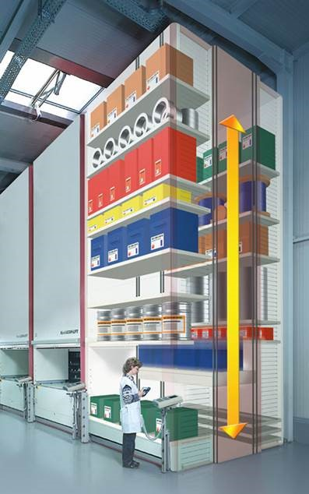

Due to the varying machine configurations, layouts, and tray sizes available, evaluation of the technology can be rather complex. O’Neal can help you evaluate the technology, determine the optimal size and layout, prove the business case, and fully integrate the automated system.

VLM vs Other Technologies

Now that you have a better understanding of VLM, it is time to discuss applications and how these applications differ from other technologies such as Vertical Carousels, Horizontal Carousels, Top-Loaded ASRS, and Shuttle Systems. Both VLM and Vertical Carousels better utilize the vertical space for product storage when compared to standard shelving, however VLM’s have the additional capability to handle deeper trays accommodating larger products than a Vertical Carousel. The deeper trays can not only handle more load capacity, but the real difference is the tray storage within each machine. The VLM’s dynamic storage height adjusts individual tray locations for varying product heights within each tray, compared to the Vertical Carousel’s fixed tray locations. Compared to a Horizontal Carousel, VLM provide better use of the height in a facility allowing for better cube utilization in a smaller footprint. Although, with increasing height, users may experience an impact to the throughput rate and a reduction in the overall capability of the machine. If throughput begins to be a limiting factor, other systems such as top-loaded ASRS’s, mini-loads, and shuttle systems should be considered.

VLM Initial Evaluation

Before jumping into the data to determine what size and how many VLM would be needed for a process, a couple of simple questions should be asked to confirm whether or not VLM meet your business needs:

On average, how many lines per order will be processed?
- If the average lines per order is greater than one, consolidation may be required across multiple VLM or multiple tray presentations. Higher lines-per-order may indicate VLM are not the right solution, since the consolidation time will reduce the time saved by bringing the goods to the person.

What throughput is required for the operation?
- Each VLM can deliver up to 350 presentations (trays) per hour depending on the configuration/manufacturer, however, this number does not consider tray dwell time for operators to load or pick product. Loading times vary between 15-30 seconds and picking from 5-10 seconds. This puts the effective VLM throughput between 100-240 presentations per hour. Throughput is critical to understand. In conjunction with the product storage requirements, it will indicate if VLM are the appropriate technology, will help to determine the number of VLM needed, and can impact the layout and storage configuration decisions that must be made.

After reviewing the above questions and verifying your process fits the initial evaluation constraints, it is time to dive into the calculations for further assessment and determining the number, size, and configuration of VLM required.

Info Needed to Determine Number of VLM

One of the first steps in determining whether a VLM solution is the correct application is to collect and verify each SKU’s Length, Width, Height, and Weight of both the Eaches and Cases being evaluated for storage. This data is compiled in a SKU Item Master and can be used in the evaluation of the various tray and machine sizes to determine the optimal solution for your products. During the evaluation process O’Neal will identify VLM-eligible SKUs and utilize the dimension/weight data to determine the optimal tray size(s) and configurations.

In parallel, O’Neal will utilize your business data to evaluate each SKU’s velocity and determine if additional SKUs should be eliminated from consideration due to the frequency they are picked. Depending on the velocity of each SKU and considering the amount of space required to accommodate the Days on Hand (DoH) storage targets a SKU may prove to be a less than optimal candidate for storage in a VLM. O’Neal utilizes your business data to complete a deep-dive analysis and develop a list of VLM-eligible SKUs.

After finalizing a comprehensive list of VLM-eligible SKUs, O’Neal will complete further analysis to determine the optimal compartment size/s of each tray. Through further evaluation of your data O’Neal will determine the required inventory and provide you with an understanding of the storage configuration and total footprint required.

From the information above, a few of the limiting factors to consider in the evaluation of VLM are the product dimensions/weights, Days on Hand targets, SKU velocity, available floor space, and clear-height availability for the machine. Once deciding VLM is the appropriate technology for your business, understanding the necessary facility preparations/modifications and associated timelines required are critical to a successful implementation. In addition to the items outlined, a few additional considerations should be made:
- Structural design/adequacy of the slab to ensure it meets the required flatness/levelness criteria and provides the structural stability needed to support the weight of each machine
- Electrical and Network requirements
- Fire protection requirements/implications
- Process flow of the VLM and how it interacts with the auxiliary processes
- Impacts to Life Safety/Egress within your facility

O’Neal’s expertise with Automated Systems and our in-house Civil, Structural, Architectural, Mechanical, Electrical, Plumbing, Fire Protection, and Process Engineers are here to help you navigate this process and ensure a successful integration. Now that you know the basics of evaluating VLM, start compiling your Item Master to review, and let O’Neal help you decide if VLM is the right technology for you.

